Across the universe The Beatles - 1968 (Tonalité originale en C#)

Rythme : B . B Bh
G Em Bm Bm

Words are flowing out like endless rain into a paper cup
Am7 Am7 D D7
They slither while they pass they slip away across the universe
G Em Bm Bm
Pools of sorrow, waves of joy are drifting through my opened mind
Am7 Cm Cm
Possessing and caressing me

G G G G D7(sus4) D7(sus4)
Jai Guru De-va Om
D D D7 D7
Refrain
Nothing's gonna change my world
C C G G x 2
Nothing's gonna change my world

G Em Bm Bm
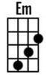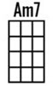
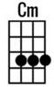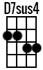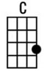
Images of broken light which dance before me like a million eyes
Am7 Am7 D D7
They call me on and on across the universe
G Em Bm Bm
Thoughts meander like a restless wind inside a letterbox
Am7 Am7 D D7
They tumble blindly as they make their way across the universe

Refrain

G Em Bm Bm
Sounds of laughter, shades of life are ringing through my opened ears
Am7 Cm Cm
Inciting and inviting me
G Em Bm Bm Am7
Limitless, undying love which shines around me like a million suns
Am7 D D7
And calls me on and on across the universe

Refrain

G G G G…
Jai Guru De-va (x 3) Jai Guru Deva
G. V1

